

Visvesvaraya Technological University, Belagavi.

REPORT OF PROJECT WORK
on
“MEMS BASED DISTRIBUTED SENSOR NETWORK FOR LANDSLIDE PREDICTION AND ALERT GENERATION ”

Project Report submitted in partial fulfillment of the requirement for the award of the degree of
Bachelor of Engineering in
Electronics and Communication Engineering
For the academic year 2025-26

Submitted by
USN: Name:
1CR22EC140 MEDHA DK
1CR22EC141 MEGHANA PS
1CR22EC145 MOHAMMED SHOAIB

Under the guidance of Dr. Eisha Akanksha
Associate Professor Department of ECE CMRIT, Bengaluru

Department of Electronics and Communication Engineering

CMR Institute of Technology, Bengaluru – 560 037 DEPARTMENT OF ELECTRONICS AND COMMUNICATION ENGINEERING

ACKNOWLEDGEMENT

The satisfaction and euphoria that accompany the successful completion of any task would be incomplete without the mention of people who made it possible, whose consistent guidance and encouragement crowned our efforts with success.
We consider it as our privilege to express the gratitude to all those who guided in the completion of the project.

We express my gratitude to Principal, Dr. Sanjay Jain, for having provided me the golden opportunity to undertake this project work in their esteemed organization.

We sincerely thank Dr. Pappa M, HOD, Department of Electronics and Communication Engineering, CMR Institute of Technology for the immense support given to me.

We express my gratitude to our project guide Dr. Eisha Akanksha, Associate professor, for her support, guidance and suggestions throughout the project work.

Last but not the least, heartful thanks to our parents and friends for their support. Above all, we thank the Lord Almighty for His grace on us to succeed in this endeavor.

MEDHA DK (1CR22EC140)
MEGHANA PS (1CR22EC141)
MOHAMMED SHOAIB(1CR22EC145)

Table of Contents

CHAPTER 1 1
INTRODUCTION 1
CHAPTER 2 3
LITERATURE SURVEY 3
CHAPTER 3 6
METHODOLOGY 6
  - Existing Method 6
  - Objectives 6
  - Proposed System 7
  - proposed Method 7
  - Proposed Solution 8
CHAPTER 4 9
HARDWARE AND SOFTWARE 9
  - Software Requirement 9
    - Embedded C 10
    - Arduino IDE 11
  - Hardware Requirements 16
    - Arduino 16
    - LCD 24
    - MEMS Sensor 32
    - Raindrop Sensor 33
    - GSM 37
    - Power Supply 40
    - Transformer 41
    - Rectifier 41
    - Capacitor 42
    - Voltage regulators 42
CHAPTER 5 44
IMPLEMENTATION ALGORITHM AND FLOWCHART 44
  - Implementation Algorithm 44
  - Flowchart 45
CHAPTER 6 46
RESULTS 46
  - Data Collection 46
  - Data Processing 46
  - Threshold Breach Detection 46
  - Overall System Performance 47
  - Analysis Of Results 47
6.5.1 Landslide Events 48

CHAPTER 7 50
APPLICATIONS AND ADVANTAGES 50
  - Applications 50
  - Advantages 51
REFERENCES 52

List of Figures | pg no:
Figure 3.1 Block Diagram 1 | 7
Figure 3.2 Block Diagram 2 | 8
Figure 3.3 Block Diagram 3 | 9
Figure 4.2.1a Arduino Types | 16
Figure 4.2.1b Microcontroller | 17
Figure 4.2.1c Arduino UNO | 18
Figure 4.2.1d Atmega328 Microcontroller | 19
Figure 4.2.1e Arduino UNO Pinout | 20
Figure 4.2.1f communication And Programming | 23
Figure 4.2.2a LCD Front View | 26
Figure 4.2.2b LCD Back View | 26
Figure 4.2.2c LCD Pin Diagram | 26
Figure 4.2.2d Block Diagram Of LCD Display | 29
Figure 4.2.3a MEMS Sensor | 33
Figure 4.2.4a Raindrop Sensor | 33
Figure 4.2.4b Raindrop Sensor Connection | 35
Figure 4.2.4c Raindrop Sensor Board | 35
Figure 4.2.4d Conditions Of Raindrop Sensor | 36
Figure 4.2.5a GSM Modem | 39
Figure 4.2.5b GSM Architecture | 40
Figure 4.2.6a Power Supply | 40
Figure 4.2.7a Transformer Circuit | 41
Figure 4.2.7b Transformer Figure 4.2.8a Rectifier Circuit | 41  42
Figure 4.2.8b Rectifier | 42
Figure 4.2.9a Capacitor | 42
Figure 4.2.10a 7805 Voltage Regulator With Pinout | 43
Figure 4.2.10b 7812 Voltage Regulator With Pinout | 43
List of Tables
Table A Arduino UNO Technical Specifications | 22
Table B Pin Description | 27
Table C Command Codes For LCD | 28
Table D Control And Display Commands | 31
Table E Pin Configuration Of Rain Drop Sensor | 34
Table F Test Cases | 47

NETWORKED MEMS PRESSURE SENSOR SYSTEM FOR LANDSLIDE MONITORING

Chapter 1

INTRODUCTION

Landslides pose a significant threat, particularly in regions prone to heavy rainfall and unstable geological conditions. They not only disrupt communities but also cause extensive economic losses and environmental damage. Traditional methods of landslide monitoring often involve manual observation or the use of isolated sensors, such as piezometers or inclinometers, which are costly and may not provide real-time data over large areas. This limitation has driven the need for more advanced, cost-effective systems that can offer continuous and real-time monitoring to detect early warning signs of landslides, such as soil pressure changes and rainfall intensity.

The main issue in current landslide detection systems is their inability to provide timely alerts due to the lack of real-time data integration. Early detection of increased pore water pressure and rainfall is critical for predicting landslides, but conventional systems either rely on periodic data collection or manual intervention, leading to delayed responses. As a result, many regions at risk remain vulnerable, as authorities do not receive alerts soon enough to initiate evacuation or preventive measures. Addressing this gap, the proposed system focuses on improving landslide detection through automated, networked sensors that continuously monitor soil conditions and weather patterns.

The objective of this research is to design a Networked MEMS Pressure Sensor System for Landslide Monitoring that can effectively detect abnormal soil pressure and rainfall, which are key precursors to landslides. By employing two MEMS pressure sensors at different locations and a raindrop sensor, the system captures real-time data related to soil and weather conditions. An Arduino microcontroller is used to manage the data and trigger alerts through a GSM module, which sends SMS notifications to authorities, while an on-site buzzer provides immediate local warnings. The system aims to reduce the risk of landslides by offering timely alerts, enabling authorities to take preventive action.

In [1] Existing literature has extensively covered the role of sensor networks in environmental monitoring. Research by Nguyen et al. (2018) demonstrated the effectiveness of wireless sensor networks (WSNs) in detecting landslides by monitoring soil moisture and pore water pressure. MEMS sensors have gained popularity due to their small size, low power consumption, and high accuracy, making them ideal for geotechnical monitoring. In [2] Studies like that of [2]Sundararajan et al. (2017) emphasize the role of MEMS sensors in providing continuous soil pressure data, which is crucial for landslide prediction. However, many of these systems are either limited by their geographical coverage or lack the integration of real-time rainfall data, which is often a major landslide trigger. Additionally, systems that combine both soil pressure and rainfall monitoring tend to be costly and difficult to scale. This research aims to bridge these gaps by offering a cost-effective, scalable solution that integrates both types of sensors, improving the system’s overall reliability and expanding its usability in high-risk areas.

By advancing the integration of MEMS sensors and real-time rainfall data, this project provides a more comprehensive approach to landslide detection. The system’s ability to offer both local and remote alerts enhances its practicality, making it a valuable tool for regions vulnerable to landslides.

Chapter 2

LITERATURE SURVEY

- Landslide Monitoring Using Wireless Sensor Networks: Recent research by Nguyen et al. (2018) highlights the integration of wireless sensor networks (WSNs) for landslide monitoring, emphasizing the use of sensors such as soil moisture, pore water pressure, and rainfall detectors. The study demonstrated how wireless communication enhances real-time data collection and analysis in remote landslide-prone areas. These systems provide early warnings by transmitting data to central databases for immediate processing. The integration of low-power MEMS sensors into these networks is seen as an effective approach to expanding the coverage area and enhancing system longevity, making it suitable for large- scale environmental monitoring.

- MEMS Sensors for Soil Pressure Monitoring in Geotechnical Engineering In the field of geotechnical engineering, Sundararajan et al. (2017) explored the application of MEMS pressure sensors for monitoring soil pressure, particularly in landslide-prone areas. MEMS sensors offer advantages such as small size, high accuracy, and low power consumption. The study emphasized the role of these sensors in monitoring pore water pressure and soil stability, critical factors in assessing landslide risk. MEMS-based sensor networks provide a scalable, cost-effective solution for continuous soil pressure monitoring, facilitating early detection of soil instability and improving landslide prediction systems.

- Rainfall-Induced Landslide Prediction Using Remote Sensing and GIS Liu et al. (2019) investigated the relationship between rainfall and landslides using remote sensing data and geographic information systems (GIS). The study demonstrated how rainfall patterns, soil moisture levels, and historical landslide occurrences can be analyzed to predict potential landslide events. The authors emphasized that heavy rainfall is a major trigger for landslides, and integrating real-time rainfall data into predictive models significantly improves the accuracy of risk assessments. The study also highlighted the potential of integrating raindrop sensors into monitoring systems to provide timely alerts for landslide events, especially when combined with geotechnical data from MEMS sensors.

- Integrated Landslide Early Warning Systems: A Review A comprehensive review by Yin et al. (2020) examined various landslide early warning systems (LEWS) and their effectiveness in reducing risks. The paper discusses the integration

of multiple sensing technologies, such as MEMS pressure sensors, rain gauges, and GPS-based displacement sensors, to monitor landslide-prone regions in real time. The research emphasized that combining these sensors can reduce false alarms and increase the reliability of early warning systems. Additionally, the integration of GSM modules for communication was seen as critical for sending alerts to local authorities and communities. The review concluded that systems incorporating MEMS sensors and real-time rainfall data are highly effective for landslide risk mitigation.

Recent advancements in landslide monitoring have increasingly focused on integrating Micro- Electro-Mechanical Systems (MEMS) pressure sensors and Wireless Sensor Networks (WSNs) to enhance real-time detection and early warning capabilities. These technologies offer cost-effective, scalable, and efficient solutions for monitoring landslide-prone areas. For example, a study by Ramesh et al. (2015) developed an integrated WSN system for real-time landslide monitoring, utilizing various sensors to capture geological, hydrological, and meteorological data. This system provided early warnings by analyzing sensor data to predict potential landslides, demonstrating the feasibility of using WSNs for comprehensive landslide monitoring.

A more recent study by Wang and Shi (2023) introduced a Global Navigation Satellite System Real-Time Kinematic (GNSS-RTK) landslide monitoring system based on an improved Raida criterion. This system used Raspberry Pi as the control core, GNSS-RTK technology for collecting deformation data, and NB-IoT for data transmission and cloud storage. This design enhanced monitoring accuracy by integrating real-time gross error detection and high-frequency noise removal techniques.

Additionally, Ramos et al. (2023) estimated the costs of installing monitoring sensors for Landslide Early Warning Systems (LEWS), highlighting that such systems are affordable and effective in building resilience in vulnerable communities. The research revealed that installation costs ranged from EUR 5 to EUR 41 per person, improving safety in landslide- prone areas.

In a 2024 study, Zhang et al. proposed a landslide monitoring and prediction system using geo-sensors and advanced wireless networks. This system integrated various geo-sensors to provide online monitoring and enhance the accuracy and timeliness of landslide predictions,

showcasing the growing trend of combining MEMS sensors with wireless communication technologies.

Previous literature[1] , including the work of Nguyen et al. (2018), has also emphasized the importance of WSNs in landslide monitoring. The study demonstrated how MEMS sensors, integrated into WSNs, enhance data collection and expand monitoring coverage, making them suitable for large-scale environmental applications. Sundararajan et al. (2017) further highlighted the role of MEMS pressure sensors in geotechnical engineering, where they effectively monitor soil pressure in landslide-prone regions.

However, gaps remain in integrating both soil pressure and rainfall data into a cohesive, real- time networked system for accurate early warning.[3] Liu et al. (2019) and Yin et al. (2020) identified the need for systems that combine MEMS sensors with rainfall data and utilize GSM modules for communication, reducing false alarms and improving the reliability of early warnings. Despite technological progress, current solutions often lack scalability or come at a high cost.

The Networked MEMS Pressure Sensor System for Landslide Monitoring aims to fill this gap by integrating pressure and rainfall monitoring into a real-time system. By leveraging GSM communication, it offers timely alerts and reliable detection, aligning with the latest research trends in landslide monitoring and hazard mitigation.

Chapter 3

METHODOLOGY
The proposed landslide monitoring system follows a systematic approach aimed at improving early detection and providing real-time alerts. The system consists of a network of MEMS pressure sensors and a raindrop sensor, all managed by an Arduino microcontroller. The MEMS pressure sensors are strategically placed at locations prone to landslides, detecting changes in soil pressure due to movement or saturation. The raindrop sensor monitors rainfall, a known trigger for landslides. Data from these sensors is collected in real time and processed by the Arduino, which compares the information against predefined risk thresholds. If the data crosses these thresholds, indicating a potential landslide risk, the system triggers an alert. Alerts are sent via a GSM module to designated authorities, while a local buzzer warns people in the area. The system operates efficiently, powered by a battery setup, and ensures continuous communication even in remote locations.

Existing Method
Current methods for landslide monitoring rely heavily on manual inspections or basic sensor systems, which often provide limited real-time data and cover only small geographic areas. These systems may involve traditional geotechnical instruments like piezometers or slope inclinometers that are either expensive or difficult to implement over large regions. Additionally, they lack the integration of real-time alerts and automation, leading to delayed response times during critical events. This limitation makes early detection of landslide risks less efficient, putting lives and infrastructure at greater risk.

Objectives
The primary objectives of the proposed system are:
    - Real-Time Monitoring: Provide continuous real-time data on soil pressure and rainfall to predict landslide risks.
    - Automated Early Warning: Develop an automated system that detects critical conditions and sends immediate alerts to authorities and local populations.
    - Cost-Effective Solution: Design a system that uses affordable sensors and components to ensure scalability, especially in remote and vulnerable areas.
    - Broader Geographic Coverage: Ensure the system can be easily deployed over large and geographically challenging regions by utilizing a network of MEMS sensors.

    - Improved Risk Mitigation: Enable faster response times and informed decision- making through early detection and accurate data.

Proposed system
The proposed system integrates MEMS pressure sensors and a raindrop sensor, both managed by an Arduino microcontroller. These sensors continuously monitor environmental conditions and provide real-time data on soil pressure and rainfall intensity. When abnormal pressure changes or high rainfall levels are detected, the system evaluates the data to assess the likelihood of a landslide. If a risk is identified, the Arduino triggers the GSM module to send alerts to relevant authorities via SMS or other communication channels. Additionally, a local buzzer is activated to provide immediate warnings in the affected area. This real-time monitoring and alerting system offers a significant improvement over traditional methods by enabling early risk detection and faster response times.
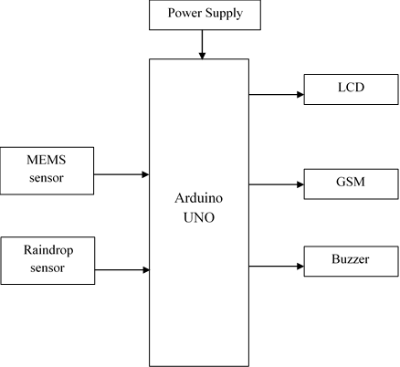
Fig 3.3 :Block diagram

Proposed Method
The proposed system combines networked MEMS pressure sensors with a raindrop sensor, managed by an Arduino, to monitor landslide risks in real time. By strategically placing MEMS sensors in multiple locations, the system detects abnormal pressure changes, while the raindrop sensor monitors rainfall as a triggering factor. When abnormal conditions are detected, a GSM

module sends immediate alerts to authorities, and a buzzer provides a local warning. This system offers real-time, cost-effective, and automated monitoring, improving response times and enabling better risk mitigation through early warnings.

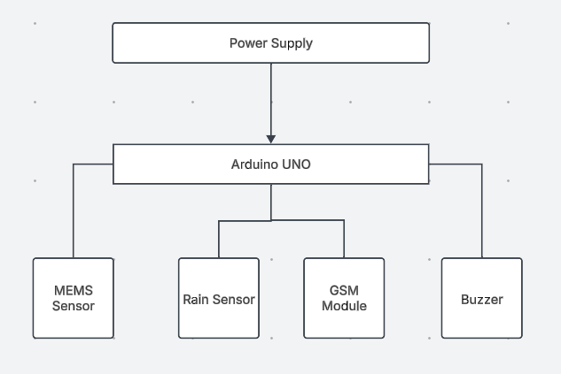

Fig 3.4 :Block diagram

Proposed solution
The proposed solution addresses the limitations of existing landslide monitoring systems by offering a cost-effective, automated, and scalable approach. The use of MEMS pressure sensors allows for continuous monitoring of soil conditions across multiple locations, providing broader coverage at a lower cost compared to traditional geotechnical instruments. The inclusion of a raindrop sensor enhances the system's ability to identify landslide risks by considering both soil pressure and rainfall data. Real-time alerts, sent via a GSM module, enable authorities to take timely action, while the local buzzer ensures immediate warnings for people nearby. This integrated solution offers improved risk mitigation, faster response times, and a more efficient monitoring process, helping to safeguard lives and infrastructure.

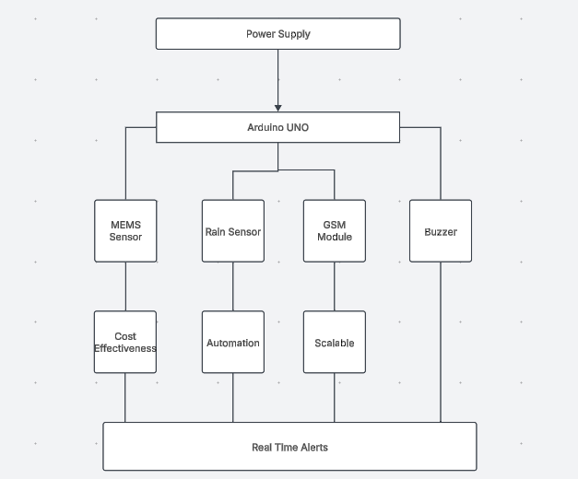

Fig 3.5 :Block diagram

Chapter 4

HARDWARE AND SOFTWARE

Software requirement:
- Embedded C
- Arduino IDE

EMBEDDED C
Implanted C makes use of KEIL IDE programming. The framework program written in implanted C can be placed away in Microcontroller. The accompanying is a portion of the actual motives behind composing applications in C as opposed to get collectively. It is much less disturbing and much less tedious to write down in C then amassing. C is less traumatic to trade and refresh. You can utilize code available in capacity libraries. C code is compact to different microcontrollers with subsequent to 0 alteration. Genuine, installed C programming need nonstandard expansions to the C driver with a view to bolster charming components, as an example, settled point range catching, numerous unmistakable reminiscence banks, and fundamental I/O operations.

In 2008, the C Standards Committee prolonged the C data to deal with these problems via giving a normal well known to all executions to purchaser to contains numerous additives not handy in standard C, for example, settled factor wide variety catching, named address spaces, and vital I/O equipment tending to.

Installed C utilize the greater part of the grammar and semantics of wellknown C, e.G., number one() paintings, variable definition, facts type statement, contingent proclamations (if, switch. Case), circles (even as, for), capacities, exhibits and strings, structures and union, piece operations, macros, unions, and so on.

Embedded systems programming

Installed frameworks writing computer programs is not quite the same as creating applications on a desktop PCs. Key attributes of an implanted framework, when contrasted with PCs, are as per the following:
•Embedded gadgets have asset limitations (restricted ROM, constrained RAM, constrained stack space, less handling power)

•Components utilized as a part of installed framework and PCs are distinctive; implanted frameworks ordinarily utilizes littler, less power devouring segments. Inserted frameworks are more fixing to the equipment.
Two remarkable components of Embedded Programming are code speed and code estimate. Code speed is represented by the handling power, timing requirements, while code size is administered by accessible program memory and utilization of programming dialect. Objective of implanted framework writing computer programs is to get greatest elements in least space and least time.
Implanted frameworks are modified utilizing distinctive sort of dialects:
- Machine Code
- Low level dialect, i.e., get together
•High level dialect like C, C++, and Java and so on.
•Application level dialect like Visual Basic, scripts, Access, and so on..,

Arduino IDE:
The Arduino IDE software is a open source software, where we can have the example codes for the beginners. In the Present world there are lot of version in the Arduino IDE in which present usage is Version1.0.5. It is very easy to connect the PC with Arduino Board.
First we have to install the Arduino IDE software according to the below instructions:
      - Insert the CD-ROM or PENDRIVE which Contains the software and then Copy the Setup File to your desired location.
      - After Copying, now click on the setup you will see an window shown below
      - click On NO, not this time. Then after NEXT
      - another Window opens –select Install from a list of specific location and NEXT
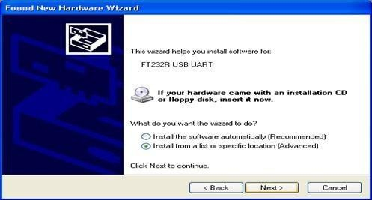

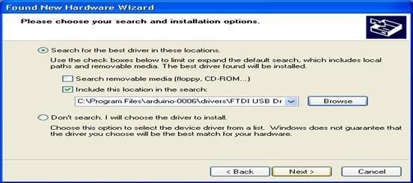
      - Select “include this location in the search” and then click Browse option available in it
      - Now it will Automatically check the USB driver and the software is installed click Finish
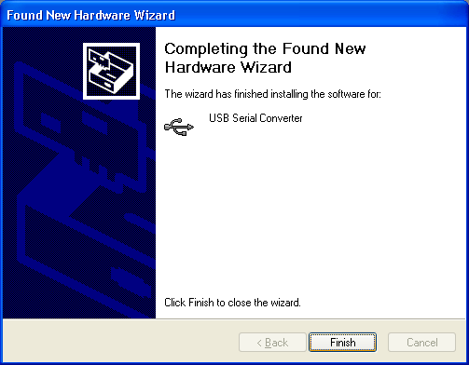
      - Now click Finish, the Software will be downloaded.
      - Now click on the Arduino IDE icon present on your Desktop. A window will appear like this.
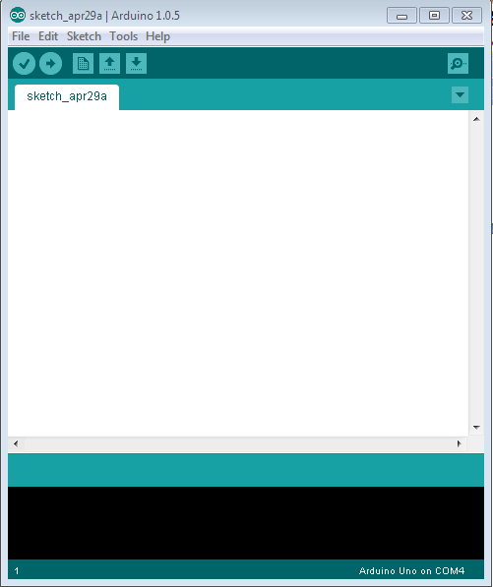

      - For any sample programs, select FILE option→Examples.
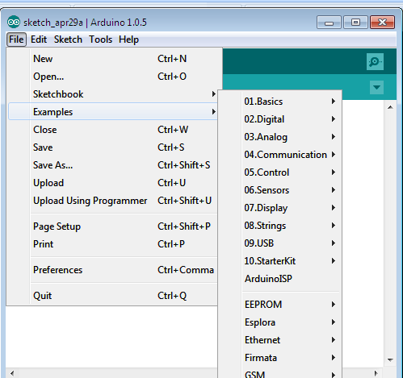
      - After Entering the Sample Code in the file, it would look like this

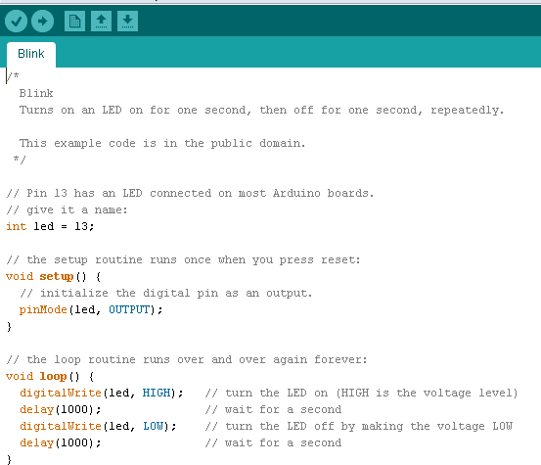

      - Before Connecting we have to select which Board is used by the user, Basically UNO. By selecting TOOLS→Board→ARDUINO UNO

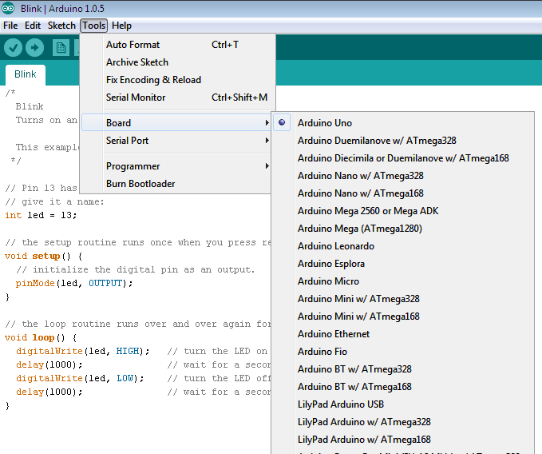
      - Now to dump the in the board Connect the Arduino to the PC through the USB port available in it. Like this TOOLS→SERIAL PORT→COMM4,COMM8 etc;

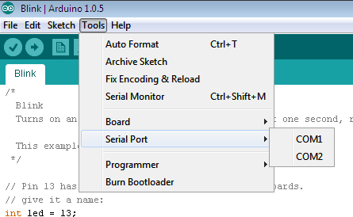

      - To verify the written Program select COMPILE option available in the software (√).
      - Now Connect the Board and select the COMM port and then UPLOAD the file in ARDUINO(→)
      - To OPEN the Previous ARDUINO FILE selects (↑) option.
      - To enter new files select NEW option.
      - To Save the Existing File, Click on the(↓).
      - To Send the Data Through Serial Monitor, Click on the (Ǫ).

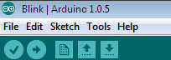
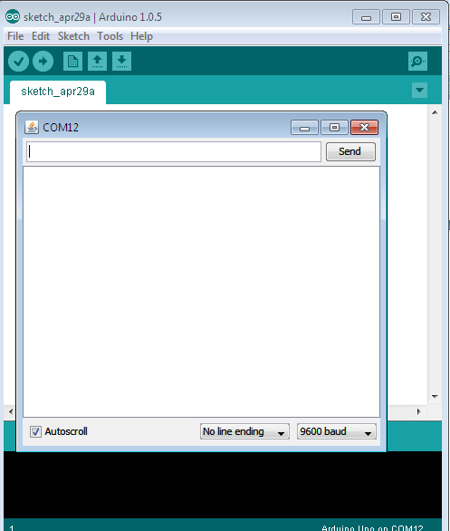

      - Here we can see the Serial Data.

Advantages:
- Automated alerts
- Cost-effective
- Early detection

Applications:
  - Landslide monitoring
  - Flood-prone area management
  - Environmental risk assessment
  - Remote hazard detection

Hardware requirements:
- Arduino
- LCD
- MEMS sensors
- Raindrop sensor
- Buzzer
- GSM module
- Power supply

Arduino:
Arduino Uno is a very valuable addition in the electronics that consists of USB interface, 14 digital I/O pins, 6 analog pins, and Atmega328 microcontroller. It also supports serial communication using Tx and Rx pins.
There are many versions of Arduino boards introduced in the market like Arduino Uno, Arduino Due, Arduino Leonardo, Arduino Mega, however, most common versions are Arduino Uno and Arduino Mega. If you are planning to create a project relating to digital electronics, embedded system, robotics, or IoT, then using Arduino Uno would be the best, easy and most economical option.
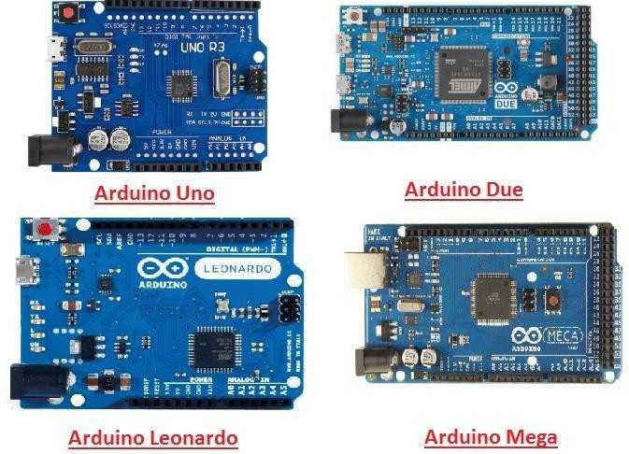

Fig: 4.2.1 a-Arduino boards

It is an open-source platform, means the boards and software are readily available and anyone can modify and optimize the boards for better functionality.

The software used for Arduino devices is called IDE (Integrated Development Environment) which is free to use and required some basic skills to learn it. It can be programmed using C and C++ language.

Some people get confused between Microcontroller and Arduino. While former is just an on system 40 pin chip that comes with a built-in microprocessor and later is a board that comes with the microcontroller in the base of the board, bootloader and allows easy access to input- output pins and makes uploading or burning of the program very easy.

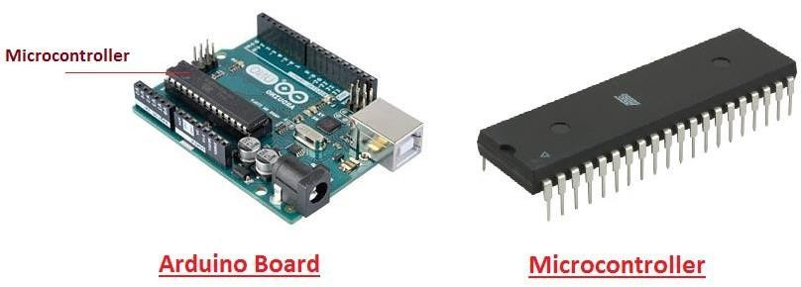
Fig: 4.2.1b-Arduino Microcontroller

While learning microcontroller requires some expertise and skills.

Nevertheless, we can say every Arduino is basically a microcontroller but not every microcontroller is an Arduino.

Introduction to Arduino

- Arduino Uno is a microcontroller board developed by Arduino.cc which is an open-source electronics platform mainly based on AVR microcontroller Atmega328.

- First Arduino project was started in Interaction Design Institute Ivrea in 2003 by David Cuartielles and Massimo Banzi with the intention of providing a cheap and flexible way to students and professional for controlling a number of devices in the real world.
- The current version of Arduino Uno comes with USB interface, 6 analog input pins, 14 I/O digital ports that are used to connect with external electronic circuits. Out of 14 I/O ports, 6 pins can be used for PWM output.
- It allows the designers to control and sense the external electronic devices in the real world

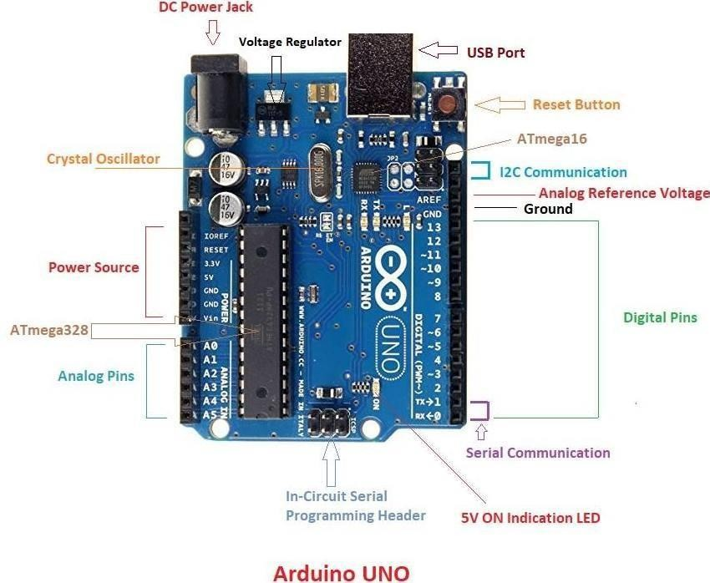
Fig: 4.2.1c-Arduino UNO
- This board comes with all the features required to run the controller and can be directly connected to the computer through USB cable that is used to transfer the code to the controller using IDE (Integrated Development Environment) software, mainly developed to program Arduino. IDE is equally compatible with Windows, MAC or Linux Systems, however, Windows is preferable to use. Programming languages like C and C++ are used in IDE.
- Apart from USB, battery or AC to DC adopter can also be used to power the board.
- Arduino Uno boards are quite similar to other boards in Arduino family in terms of use and functionality, however, Uno boards don’t come with FTDI USB to Serial driver chip.

- There are many versions of Uno boards available, however, Arduino Nano V3 and Arduino Uno are the most official versions that come with Atmega328 8-bit AVR Atmel microcontroller where RAM memory is 32KB.
- When nature and functionality of the task go complex, Mirco SD card can be added in the boards to make them store more information.

Features of Arduino
  - Arduino Uno comes with USB interface i.e. USB port is added on the board to develop serial communication with the computer.
  - Atmega328 microcontroller is placed on the board that comes with a number of features like timers, counters, interrupts, PWM, CPU, I/O pins and based on a 16MHz clock that helps in producing more frequency and number of instructions per cycle.
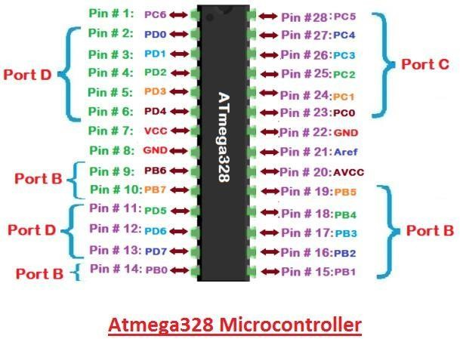
Fig: 4.2.1d-Atmega328 Microcontroller
- It is an open source platform where anyone can modify and optimize the board based on the number of instructions and task they want to achieve.
- This board comes with a built-in regulation feature which keeps the voltage under control when the device is connected to the external device.
- Reset pin is added in the board that reset the whole board and takes the running program in the initial stage. This pin is useful when board hangs up in the middle of the running program; pushing this pin will clear everything up in the program and starts the program right from the beginning.

- There are 14 I/O digital and 6 analog pins incorporated in the board that allows the external connection with any circuit with the board. These pins provide the flexibility and ease of use to the external devices that can be connected through these pins. There is no hard and fast interface required to connect the devices to the board. Simply plug the external device into the pins of the board that are laid out on the board in the form of the header.
- The 6 analog pins are marked as A0 to A5 and come with a resolution of 10bits. These pins measure from 0 to 5V, however, they can be configured to the high range using analog Reference() function and AREF pin.
- 13KB of flash memory is used to store the number of instructions in the form of code.
- Only 5 V is required to turn the board on, which can be achieved directly using USB port or external adopter, however, it can support external power source up to 12 V which can be regulated and limit to 5 V or 3.3 V based on the requirement of the project.

Arduino Pinout
  - Arduino Uno is based on AVR microcontroller called Atmega328. This controller comes with 2KB SRAM, 32KB of flash memory, 1KB of EEPROM. Arduino Board comes with 14 digital pins and 6 analog pins. ON-chip ADC is used to sample these pins. A 16 MHz frequency crystal oscillator is equipped on the board. Following figure shows the pinout of the Arduino Uno Board
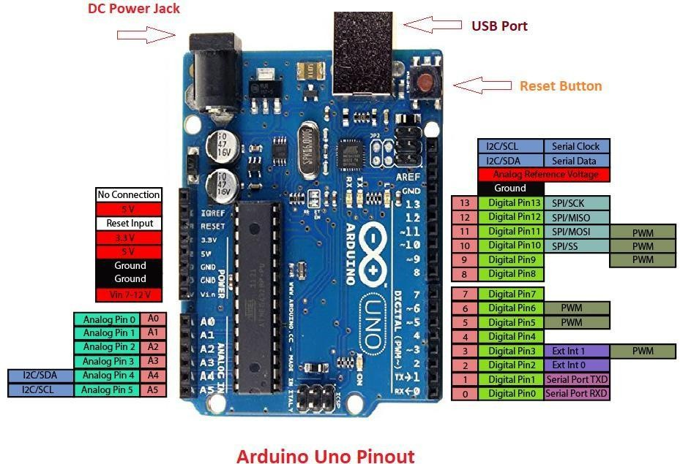
Fig: 4.2.1e-Arduino Uno pinout

Pin Description:
There are several I/O digital and analog pins placed on the board which operates at 5V. These pins come with standard operating ratings ranging between 20mA to 40mA. Internal pull-up resistors are used in the board that limits the current exceeding from the given operating conditions. However, too much increase in current makes these resisters useless and damages the device.

LED. Arduino Uno comes with built-in LED which is connected through pin 13. Providing HIGH value to the pin will turn it ON and LOW will turn it OFF.
Vin. It is the input voltage provided to the Arduino Board. It is different than 5 V supplied through a USB port. This pin is used to supply voltage. If a voltage is provided through power jack, it can be accessed through this pin.
5V. This board comes with the ability to provide voltage regulation. 5V pin is used to provide output regulated voltage. The board is powered up using three ways i.e. USB, Vin pin of the board or DC power jack.
USB supports voltage around 5V while Vin and Power Jack support a voltage ranges between 7V to 20V. It is recommended to operate the board on 5V. It is important to note that, if a voltage is supplied through 5V or 3.3V pins, they result in bypassing the voltage regulation that can damage the board if voltage surpasses from its limit.

GND. These are ground pins. More than one ground pins are provided on the board which can be used as per requirement.
Reset. This pin is incorporated on the board which resets the program running on the board. Instead of physical reset on the board, IDE comes with a feature of resetting the board through programming.
IOREF. This pin is very useful for providing voltage reference to the board. A shield is used to read the voltage across this pin which then select the proper power source.
PWM. PWM is provided by 3, 5, 6,9,10, 11pins. These pins are configured to provide 8-bit output PWM.
SPI. It is known as Serial Peripheral Interface. Four pins 10(SS), 11(MOSI), 12(MISO), 13(SCK) provide SPI communication with the help of SPI library.
AREF. It is called Analog Reference. This pin is used for providing a reference voltage to the analog inputs.

TWI. It is called Two-wire Interface. TWI communication is accessed through Wire Library. A4 and A5 pins are used for this purpose.
Serial Communication: Serial communication is carried out through two pins called Pin 0 (Rx) and Pin 1 (Tx).
Rx pin: is used to receive data while Tx pin is used to transmit data.
External Interrupts:Pin 2 and 3 are used for providing external interrupts. An interrupt is called by providing LOW or changing value.

Arduino Uno Technical Specifications

Microcontroller | ATmega328P – 8 bit AVR family microcontroller
Operating Voltage | 5V
Recommended Input Voltage | 7-12V
Input Voltage Limits | 6-20V
Analog Input Pins | 6 (A0 – A5)
Digital I/O Pins | 14 (Out of which 6 provide PWM output)
DC Current on I/O Pins | 40 Ma
DC Current on 3.3V Pin | 50 mA
Flash Memory | 32 KB (0.5 KB is used for Bootloader)
SRAM | 2 KB
EEPROM | 1 KB
Frequency (Clock Speed) | 16 MHz

Table :A- Arduino Uno Technical Specifications

Communication and Programming:
Arduino Uno comes with an ability of interfacing with other other Arduino boards, microcontrollers and computer. The Atmega328 placed on the board provides serial communication using pins like Rx and Tx.

The Atmega16U2 incorporated on the board provides a pathway for serial communication using USB com drivers. Serial monitor is provided on the IDE software which is used to send or receive text data from the board. If LEDs placed on the Rx and Tx pins will flash, they indicate the transmission of data.

Arduino Uno is programmed using Arduino Software which a cross-platform application called IDE is written in Java. The AVR microcontroller Atmega328 laid out on the base comes with built-in boot loader that sets you free from using a separate burner to upload the program on the board.

Fig: 4.2.1f-communication programming

Applications:
Arduino Uno comes with a wide range of applications. A larger number of people are using Arduino boards for developing sensors and instruments that are used in scientific research. Following are some main applications of the board.

- Embedded System
- Security and Defense System
- Digital Electronics and Robotics
- Parking Lot Counter

- Weighing Machines
- Traffic Light Count Down Timer
- Medical Instrument
- Emergency Light for Railways
- Home Automation
- Industrial Automation
There are a lot of other microcontrollers available in the market that are more powerful and cheap as compared to Arduino board. So, why you prefer Arduino Uno?

Actually, Arduino comes with a big community that is developing and sharing the knowledge with a wide range of audience. Quick support is available pertaining to technical aspects of any electronic project. When you decide Arduino board over other controllers, you don’t need to arrange extra peripherals and devices as most of the functions are readily available on the board that makes your project economical in nature and free from a lot of technical expertise.

LCD:
LCD (Liquid Crystal Display) is the innovation utilized in scratch pad shows and other littler PCs. Like innovation for light-producing diode (LED) and gas-plasma, LCDs permit presentations to be a lot more slender than innovation for cathode beam tube (CRT). LCDs expend considerably less power than LED shows and gas shows since they work as opposed to emanating it on the guideline of blocking light.
A LCD is either made with a uninvolved lattice or a showcase network for dynamic framework show. Likewise alluded to as a meager film transistor (TFT) show is the dynamic framework LCD. The uninvolved LCD lattice has a matrix of conductors at every crossing point of the network with pixels. Two conductors on the lattice send a current to control the light for any pixel. A functioning framework has a transistor situated at every pixel crossing point, requiring less current to control the luminance of a pixel.
Some aloof network LCD's have double filtering, which implies they examine the matrix twice with current in the meantime as the first innovation took one sweep. Dynamic lattice, be that as it may, is as yet a higher innovation.
A 16x2 LCD show is an essential module that is generally utilized in various gadgets and circuits. These modules more than seven sections and other multi fragment LEDs are liked. The reasons being: LCDs are affordable; effectively programmable; have no restriction of

showing exceptional and even custom characters (not at all like in seven fragments), movements, etc.

A 16x2 LCD implies 16 characters can be shown per line and 2 such lines exist. Each character is shown in a lattice of 5x7 pixels in this LCD. There are two registers in this LCD, in particular Command and Data.

The directions given to the LCD are put away by the order register. An order is a direction given to LCD to play out a predefined assignment, for example, introducing it, clearing its screen, setting the situation of the cursor, controlling presentation, and so forth. The information register will store the information that will be shown on the LCD. The information is the character's ASCII incentive to show on the LCD.

Data/Signals/Execution of LCD

Now that was all about the signals and the hardware. Let us come to data, signals and execution.

Two types of signals are accepted by LCD, one is data and one is control. The LCD module recognizes these signals from the RS pin status. By pulling the R / W pin high, data can now also be read from the LCD display. Once the E pin has been pulsed, the LCD display reads and executes data at the falling edge of the pulse, the same for the transmission case.
It takes 39-43μS for the LCD display to place a character or execute a command. It takes
1.53ms to 1.64ms except for clearing display and searching for cursor to the home position.

Any attempt to send data before this interval may result in failure in some devices to read data or execute the current data. Some devices compensate for the speed by storing some temporary registers with incoming data.
There are two RAMs for LCD displays, namely DDRAM and CGRAM. DDRAM registers the position in which the character would be displayed in the ASCII chart. Each DDRAM byte represents every single position on the display of the LCD.
The DDRAM information is read by the LCD controller and displayed on the LCD screen. CGRAM enables users to define their personalized characters. Address space is reserved for users for the first 16 ASCII characters.

Users can easily display their custom characters on the LCD screen after CGRAM has been set up to display characters.

Images of LCD Display:-
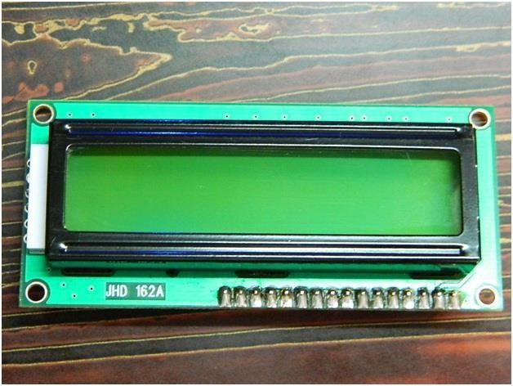
Fig: 4.2.2a- LCD – Front View
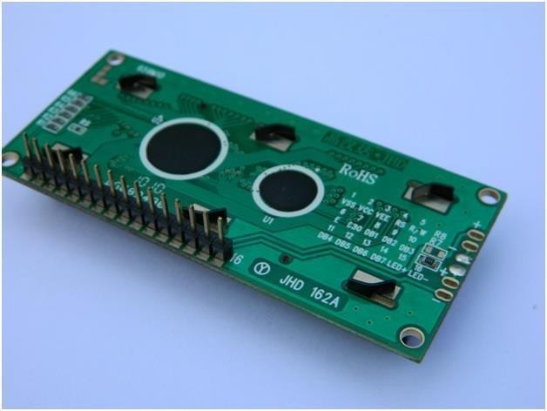
Fig: 4.2.2b- LCD – Back View

Pin Diagram:
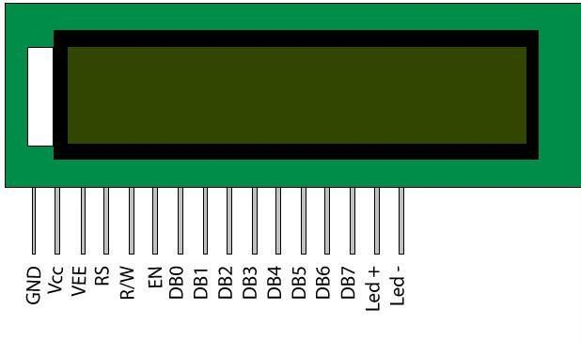
Fig: 4.2.2c-LCD pin diagram

Pin Description:

Pin No | Function | Name
1 | Ground (0V) | Ground
2 | Supply voltage; 5V (4.7V – 5.3V) | Vcc
3 | Contrast adjustment; through a variable resistor | VEE
4 | Selects command register when low; and data register when high | Register Select
5 | Low to write to the register; High to read from the register | Read/write
6 | Sends data to data pins when a high to low pulse is given | Enable
7 | 8-bit data pins | DB0
8 | 8-bit data pins | DB1
9 | 8-bit data pins | DB2
10 | 8-bit data pins | DB3
11 | 8-bit data pins | DB4
12 | 8-bit data pins | DB5
13 | 8-bit data pins | DB6
14 | 8-bit data pins | DB7
15 | Backlight VCC (5V) | Led+
16 | Backlight Ground (0V) | Led-
Table : B-Pin Descri[tion

RS (Register select)

A 16X2 LCD has two order and information registers. The determination of the register is utilized to change starting with one register then onto the next. RS=0 for the register of directions, while RS=1 for the register of information.

Command Register

The guidelines given to the LCD are put away by the direction register. An order is a direction given to LCD to play out a predefined assignment, for example, instating it, clearing its screen, setting the situation of the cursor, controlling showcase, and so on. Order preparing happens in the direction register.

Data Register:

The information register will store the information that will be shown on the LCD. The information is the character's ASCII incentive to show on the LCD. It goes to the information

register and is prepared there when we send information to the LCD. While choosing RS=1, the information register.

Read and Write Mode of LCD:

As stated, the LCD itself comprises of an interface IC. This interface IC can be perused or composed by the MCU. A large portion of the occasions we're simply going to keep in touch with the IC since perusing will make it increasingly perplexing and situations like that are exceptionally uncommon.Information such as cursor position, status completion interrupts, etc. can be read if necessary.

LCD Commands:

There are some preset commands in the LCD that we need to send to the LCD via some microcontroller. The following are some important command instructions:

Sr. No. | Hex Code | Command to LCD instruction Register
1 | 01 | Clear display screen
2 | 02 | Return home
3 | 04 | Decrement cursor (shift cursor to left)
4 | 06 | Increment cursor (shift cursor to right)
5 | 05 | Shift display right
6 | 07 | Shift display left
7 | 08 | Display off, cursor off
8 | 0A | Display off, cursor on
9 | 0C | Display on, cursor off
10 | 0E | Display on, cursor blinking
11 | 0F | Display on, cursor blinking

12 | 10 | Shift cursor position to left
13 | 14 | Shift cursor position to right
14 | 18 | Shift the entire display to the left
15 | 1C | Shift the entire display to the right
16 | 80 | Force cursor to beginning ( 1st line)
17 | C0 | Force cursor to beginning ( 2nd line)
18 | 38 | 2 lines and 5×7 matrix

Table : C :Command codes for LCD

Block Diagram of LCD Display:-

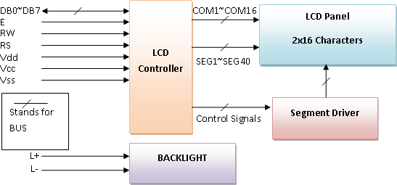

Fig: 4.2.2d- Block Diagram of LCD Display

Control and display commands

Instruc tion | Instruction Code |  |  |  |  |  |  |  |  |  | Instruction Code Description | Execut ion time
Instruc tion | R S | R/ W | D B7 | D B6 | D B5 | D B4 | D B3 | D B2 | D B1 | D B0 | Instruction Code Description | Execut ion time
Read Data From  RAM | 1 | 1 | D7 | D6 | D5 | D4 | D3 | D2 | D1 | D0 | Read data from internal RAM | 1.53-  1.64ms
Write data to RAM | 1 | 0 | D7 | D6 | D5 | D4 | D3 | D2 | D1 | D0 | Write data into internal RAM (DDRAM/CG  RAM) | 1.53-  1.64ms
Busy flag & Address | 0 | 1 | BF | A C6 | A C5 | A C4 | A C3 | A C2 | A C1 | A C0 | Busy flag (BF: 1→ LCD Busy) and contents of address counter in bits AC6-  AC0. | 39 µs
Set DDRA M  Address | 0 | 0 | 1 | A C6 | A C5 | A C4 | A C3 | A C2 | A C1 | A C0 | Set DDRAM  address in  address counter. | 39 µs
Set CGRA M  Address | 0 | 0 | 0 | 1 | A C5 | A C4 | A C3 | A C2 | A C1 | A C0 | Set CGRAM  Address in  address counter. | 39 µs
Functio n Set | 0 | 0 | 0 | 0 | 1 | DL | N | F | X | X | Set interface  data length (DL: 4bit/8bit), Numbers of display line (N: 1-line/2-line) display font type (F:0→ 5×8 dots, F:1→  5×11 dots) | 39 µs
Cursor or Display Shift | 0 | 0 | 0 | 0 | 0 | 1 | S/ C | R/ L | X | X | Set cursor moving and  display shift control bit, and the direction  without | 39 µs

 |  |  |  |  |  |  |  |  |  |  | changing DDRAM data
Display & Cursor On/Off | 0 | 0 | 0 | 0 | 0 | 0 | 1 | D | C | B | Set Display(D),Cur sor(C) and cursor blink(b)  on/off control | 39 µs
Entry Mode Set | 0 | 0 | 0 | 0 | 0 | 0 | 0 | 1 | I/D | SH | Assign cursor moving direction and  enable shift  entire display. | 0µs
Return Home | 0 | 0 | 0 | 0 | 0 | 0 | 0 | 0 | 1 | X | Set DDRAM  Address to  “00H” from AC and return cursor to its original position if  shifted. | 43µs
Clear Display | 0 | 0 | 0 | 0 | 0 | 0 | 0 | 0 | 0 | 1 | Write “20H” to DDRAM and set DDRAM Address to  “00H” from  AC | 43µs
Table : D- Control and display commands

4-bit and 8-bit Mode of LCD:

The LCD can work in two striking modes, the 4-bit mode and the 8-bit mode. We send the information snack through snack in 4 bit mode, first upper chomp, by then lower snack. For those of you who don't have the foggiest idea what a goody is: a chomp is a four-piece gathering, so a byte's lower four bits (D0-D3) are the lower snack, while a byte's upper four bits (D4-D7) are the higher snack. This enables us to send 8 bit data. This connects with us to send 8 bit data. Whereas in 8 bit mode we can send the 8-bit information truly in one stroke since we utilize all the 8 information lines. You need to get it now; yes 8-bit mode is quicker and immaculate than 4-bit mode. In any case, the fundamental shortcoming is that it needs 8

microcontroller-related information lines. This will result in our MCU coming up short on I/O pins, so 4-bit mode is extensively utilized. To set these modes, no control pins are used.

MEMS Sensor:

The term MEMS stands for micro-electro-mechanical systems. These are a set of devices, and the characterization of these devices can be done by their tiny size & the designing mode. The designing of these sensors can be done with the 1- 100-micrometer components. These devices can differ from small structures to very difficult electromechanical systems with numerous moving elements beneath the control of incorporated micro-electronics. Usually, these sensors include mechanical micro-actuators, micro-structures, micro-electronics, and micro-sensors in one package. This article discusses what is a MEMS sensor, working principle, advantages and it’s applications

What is a MEMS Sensor?

MEMS are low-cost, and high accuracy inertial sensors and these are used to serve an extensive range of industrial applications. This sensor uses a chip-based technology namely micro- electro-mechanical-system. These sensors are used to detect as well as measure the external stimulus like pressure, after that it responds to the pressure which is measured pressure with the help of some mechanical actions. The best examples of this mainly include revolving of a motor for compensating the pressure change.

The MEMS accelerometers can be divided into two important micro system architectures: piezo resistive and capacitive. Even though both of these two types of accelerometers possess internal proof masses which are excited by acceleration, the differences of these two architectures lie in the transduction mechanism which is used to the movement correlation of the internal proof mass to accelerate.
The Capacitive accelerometers possess a differential capacitor whose balance is disrupted by the proof mass movement. Piezo resistive accelerometers commonly rely on inducing, which attach the proof mass to the sensor which is used for identification of the movement of the mass.
Fujitsu successfully developed the ‘FAR-S2AB’ series, 3-axis Accelerometer, using state-of- the-art MEMS technology. This small and highly sensitive accelerometer can detect acceleration, inclination and vibration by measuring the motion in the x-, y-, and z-axis

simultaneously. The MEMS 3-axis accelerometer consists of a Mass at the centre of the sensor’s chip, which is suspended by 4 Beams doped with Piezo resistive material.
By sensing the mounting angle, the sensor can assist in compensating for the devices mounting angle, and therefore makes it possible to use ACCELEROMETER FACTSHEET MEMS 3-AXIS ACCELEROMETER normal SMD technology in high density boards, and also to realise the precise detection of the inclination angle. An interface IC within the sensor package also has temperature sensing and self-diagnosis functions.
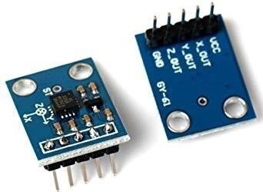
Fig: 4.2.3a- MEMS Sensor

Raindrop Sensor:
Raindrop Sensor is a tool used for sensing rain. It consists of two modules, a rain board that detects the rain and a control module, which compares the analog value, and converts it to a digital value. The raindrop sensors can be used in the automobile sector to control the windshield wipers automatically, in the agriculture sector to sense rain and it is also used in home automation systems.
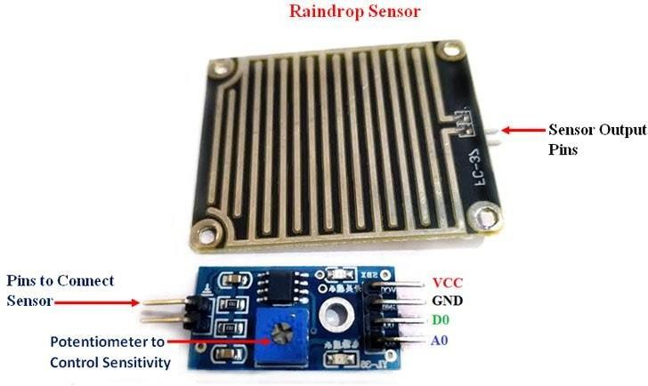
Fig: 4.2.4a-Raindrop sensor

Pin Configuration of Rain Sensor:

S.No: | Name | Function
1 | VCC | Connects supply voltage- 5V
2 | GND | Connected to ground
3 | D0 | Digital pin to get digital output
4 | A0 | Analog pin to get analog output
Table : E- Pin Configuration of Rain Sensor

Raindrop Sensor Features:

- Working voltage 5V
- Output format: Digital switching output (0 and 1), and analog voltage output AO
- Potentiometer adjust the sensitivity
- Uses a wide voltage LM393 comparator
- Comparator output signal clean waveform is good, driving ability, over 15mA
- Anti-oxidation, anti-conductivity, with long use time
- With bolt holes for easy installation
- Small board PCB size: 3.2cm x 1.4cm

How to use Raindrop sensor:

Interfacing the raindrop sensor with a microcontroller like 8051, Arduino, or PIC is simple. The rain board module is connected with the control module of the raindrop sensor as shown in the below diagram.

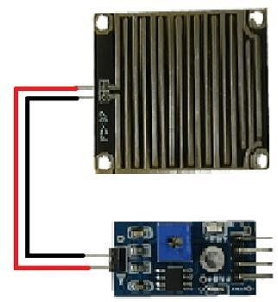
Fig: 4.2.4b – Raindrop sensor connection
The control module of the raindrop sensor has 4 outputs. VCC is connected to a 5V supply. The GND pin of the module is connected to the ground. The D0 pin is connected to the digital pin of the microcontroller for digital output or the analog pin can be used. To use the analog output, the A0 pin can be connected to the ADC pin of a microcontroller. In the case of Arduino, it has 6 ADC pins, so we can use any of the 6 pins directly without using an ADC converter. The sensor module consists of a potentiometer, LN393 comparator, LEDs, capacitors and resistors. The pinout image above shows the components of the control module. The rain board module consists of copper tracks, which act as a variable resistor. Its resistance varies with respect to the wetness on the rain board.
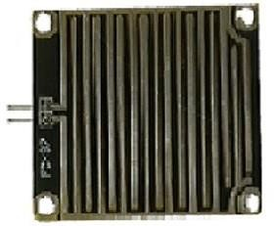
Fig: 4.2.4c-Raindrop sensor board

Working of Rain Sensor:

Case1: When the input of the inverting terminal is higher than the input of the non-inverting terminal.
Case2: If the input of the inverting terminal is lower than the input of the non-inverting terminal.
The input to the inverting terminal is set to a certain value by varying the potentiometer and the sensitivity is set. When the rain board module’s surface is exposed to rainwater, the surface of the rainboard module will be wet, and it offers minimum resistance to the supply voltage. Due to this, the minimum voltage will be appearing at the non-inverting terminal of LM393 Op-Amp. The comparator compares both inverting and non-inverting terminal voltages. If the condition falls under case(1), the output of the Op-Amp will be digital LOW. If the condition falls under case(2), the output of the Op-Amp will be digital HIGH. The below diagram shows the equivalent circuit of both the conditions.
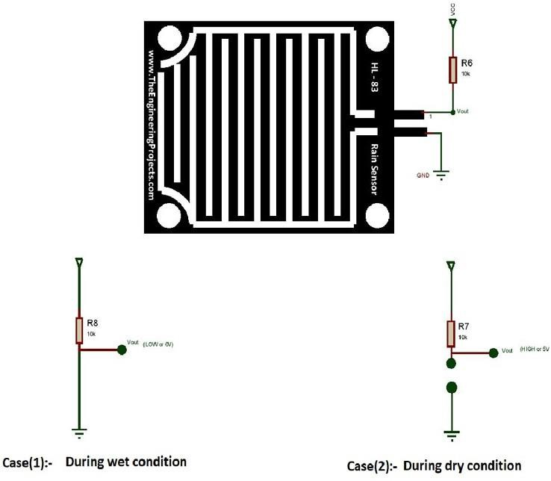
Fig: 4.2.4d- Conditions of raindrop sensor

When the A0 pin is connected to the microcontroller, an additional analog to digital converter (ADC) circuit is used. In the case of Arduino, it consists of 6 ADC pins, which can be directly used for calculation purposes.

GSM
GSM is a mobile communication modem; it is stands for global system for mobile communication (GSM). The idea of GSM was developed at Bell Laboratories in 1970. It is widely used mobile communication system in the world. GSM is an open and digital cellular technology used for transmitting mobile voice and data services operates at the 850MHz, 900MHz, 1800MHz and 1900MHz frequency bands.

GSM system was developed as a digital system using time division multiple access (TDMA) technique for communication purpose. A GSM digitizes and reduces the data, then sends it down through a channel with two different streams of client data, each in its own particular time slot. The digital system has an ability to carry 64 kbps to 120 Mbps of data rates.

There are various cell sizes in a GSM system such as macro, micro, pico and umbrella cells. Each cell varies as per the implementation domain. There are five different cell sizes in a GSM network macro, micro, pico and umbrella cells. The coverage area of each cell varies according to the implementation environment.
Time Division Multiple Access

TDMA technique relies on assigning different time slots to each user on the same frequency. It can easily adapt to data transmission and voice communication and can carry 64kbps to 120Mbps of data rate.

GSM Architecture

A GSM network consists of the following components:

- A Mobile Station: It is the mobile phone which consists of the transceiver, the display and the processor and is controlled by a SIM card operating over the network.
- Base Station Subsystem: It acts as an interface between the mobile station and the network subsystem. It consists of the Base Transceiver Station which contains the radio transceivers and handles the protocols for communication with mobiles. It also consists of the Base Station Controller which controls the Base Transceiver station and acts as a interface between the mobile station and mobile switching centre.
- Network Subsystem: It provides the basic network connection to the mobile stations. The basic part of the Network Subsystem is the Mobile Service Switching Centre which

provides access to different networks like ISDN, PSTN etc. It also consists of the Home Location Register and the Visitor Location Register which provides the call routing and roaming capabilities of GSM. It also contains the Equipment Identity Register which maintains an account of all the mobile equipments wherein each mobile is identified by its own IMEI number. IMEI stands for International Mobile Equipment Identity.

Features of GSM Module:

- Improved spectrum efficiency
- International roaming
- Compatibility with integrated services digital network (ISDN)
- Support for new services.
- SIM phonebook management
- Fixed dialing number (FDN)
- Real time clock with alarm management
- High-quality speech
- Uses encryption to make phone calls more secure
- Short message service (SMS)

The security strategies standardized for the GSM system make it the most secure telecommunications standard currently accessible. Although the confidentiality of a call and secrecy of the GSM subscriber is just ensured on the radio channel, this is a major step in achieving end-to- end security.

GSM Modem

A GSM modem is a device which can be either a mobile phone or a modem device which can be used to make a computer or any other processor communicate over a network. A GSM modem requires a SIM card to be operated and operates over a network range subscribed by the network operator. It can be connected to a computer through serial, USB or Bluetooth connection.

A GSM modem can also be a standard GSM mobile phone with the appropriate cable and software driver to connect to a serial port or USB port on your computer. GSM modem is usually preferable to a GSM mobile phone. The GSM modem has wide range of applications

in transaction terminals, supply chain management, security applications, weather stations and GPRS mode remote data logging.
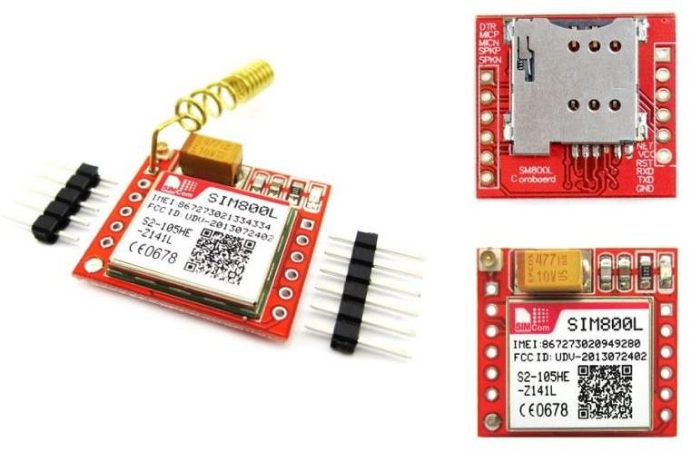

Fig: 4.2.5a- GSM modem

It requires a SIM (Subscriber Identity Module) card just like mobile phones to activate communication with the network. Also they have IMEI (International Mobile Equipment Identity) number similar to mobile phones for their identification. A GSM/GPRS MODEM can perform the following operations:
- Receive, send or delete SMS messages in a SIM.
- Read, add, search phonebook entries of the SIM.
- Make, Receive, or reject a voice call.

The MODEM needs AT commands, for interacting with processor or controller, which are communicated through serial communication. These commands are sent by the controller/processor. The MODEM sends back a result after it receives a command. Different AT commands supported by the MODEM can be sent by the processor/controller/computer to interact with the GSM and GPRS cellular network.

GSM Architecture

The GSM architecture is divided into Radio Subsystem, Network and Switching Subsystem and the Operation Subsystem. The radio sub system consists of the Mobile Station and Base Station Subsystem.

The mobile station is generally the mobile phone which consists of a transceiver, display and a processor. Each handheld or portable mobile station consists of a unique identity stored in a

module known as SIM (Subscriber Identity Chip). It is a small microchip which is inserted in the mobile phone and contains the database regarding the mobile station.
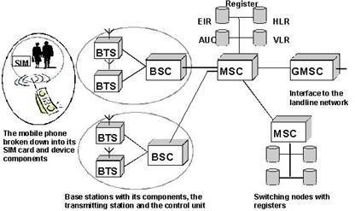

Fig:4.2.5b- GSM Architecture

Power supply:
A power supply is a component that provides at least one electrical charge with power. It typically converts one type of electrical power to another, but it can also convert a different Energy form in electrical energy, such as solar, mechanical, or chemical.
A power supply provides electrical power to components. Usually the term refers to devices built into the powered component. Computer power supplies, for example, convert AC current to DC current and are generally located along with at least one fan at the back of the computer case.
Most computer power supplies also have an input voltage switch that, depending on the geographic location, can be set to 110v/115v or 220v/240v. Due to the different power voltages supplied by power outlets in different countries, this switch position is crucial.
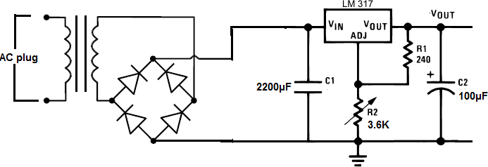
Fig: 4.2.6a-Power supply

Some basic components used in the supply of power:

Transformer:
A transformer is a static electrical gadget that exchanges control between at least two circuits. A fluctuating current creates a changing attractive motion in one transformer curl, which thus actuates a differing electromotive power over a second loop twisted around a similar center.

Without a metallic association between the two circuits, electrical vitality can be exchanged between the two loops. The enlistment law of Faraday found in 1831 portrayed the impact of prompted voltage in any curl because of the changing attractive flux surrounded by the coil.
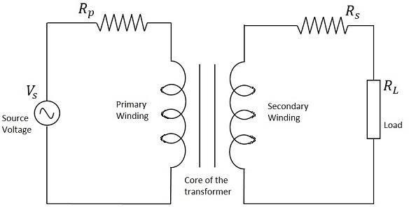

Circuit of transformer Fig: 4.2.7a
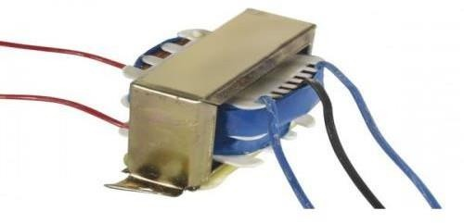

Fig : 4.2.7b Transformer

Rectifier:

A rectifier is an electrical device that converts alternating current (AC), which periodically reverses direction, to direct current (DC), which flows in only one direction. The process is known as rectification, since it "straightens" the direction of current.

Rectifiers have many uses, but are often found to serve as components of DC power supplies and direct power transmission systems with high voltage. Rectification can be used in roles other than direct current generation for use as a power source.

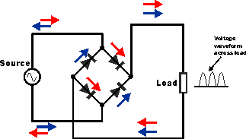
Fig : 4.2.8a Circuit of rectifier
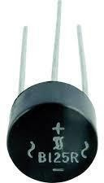
Fig: 4.2.8b Rectifier

    - Capacitors:
Capacitors are used to attain from the connector the immaculate and smoothest DC voltage in which the rectifier is used to obtain throbbing DC voltage which is used as part of the light of the present identity. Capacitors are used to acquire square DC from the current AC experience of the current channels so that they can be used as a touch of parallel yield.
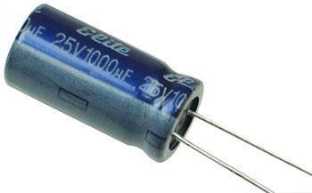

Fig : 4.2.9d Capacitor

Voltage regulators:
The 78XX voltage controller is mainly used for voltage controllers as a whole. The XX speaks to the voltage delivered to the specific gadget by the voltage controller as the yield. 7805 will supply and control 5v yield voltage and 12v yield voltage will be created by 7812.
The voltage controllers are that their yield voltage as information requires no less than 2 volts. For example, 7805 as sources of information will require no less than 7V, and 7812, no less

than 14 volts. This voltage is called Dropout Voltage, which should be given to voltage controllers.
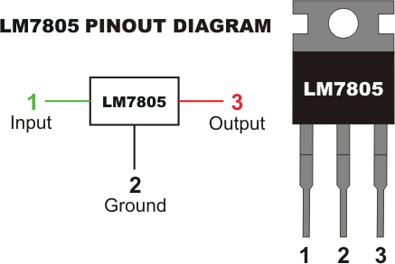
Fig : 4.2.10a 7805 voltage regulator with pinout
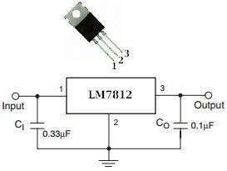
Fig : 4.2.10b 7812 voltage regulator with pinout

Chapter 5

IMPLEMENTATION ALGORITHM AND FLOWCHART

Implementation Algorithm STEP 1:Start System
    - Initialize the Arduino microcontroller.
    - Power up the MEMS pressure sensors, raindrop sensor, GSM module, and buzzer.

STEP 2:Sensor Calibration
    - Calibrate MEMS pressure sensors and raindrop sensor to ensure accurate readings.
    - Set thresholds based on historical data for both pressure and rainfall levels.

STEP 3:Data Collection
    - Continuously collect real-time data from the MEMS pressure sensors and raindrop sensor.
    - Store the sensor readings in Arduino’s memory for further processing.

STEP 4:Data Processing
    - Compare the current sensor readings with the predefined thresholds.
    - Use a conditional check to determine if the pressure sensor readings indicate soil instability or if the raindrop sensor shows excessive rainfall.

STEP 5:Threshold Breach Detection
    - If the collected data exceeds the thresholds, mark the situation as a potential landslide risk.
    - If thresholds are not exceeded, continue monitoring and repeat the process.

STEP 6:Alert Triggering
    - If a potential risk is detected, activate the local warning system (buzzer).
    - Simultaneously, the Arduino sends an alert through the GSM module to the designated authorities, providing details about the risk.

STEP 7:Repeat Monitoring
    - Return to data collection and continue monitoring the environmental conditions for further risks.
    - Ensure the system operates continuously in a loop.

Flowchart

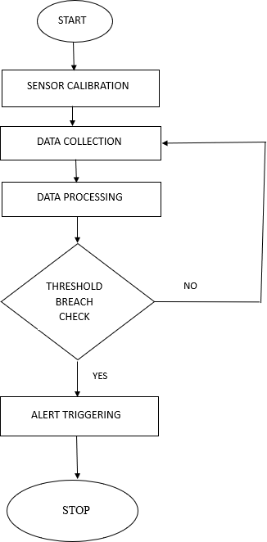

Chapter 6

RESULTS
The MEMS pressure sensors were carefully calibrated to ensure that they provide accurate and reliable data for landslide detection. Calibration was performed by comparing sensor readings with known reference pressure values under controlled conditions. The accuracy of the sensors was found to be within ±0.5 kPa, which is sufficient for detecting significant pressure changes caused by soil movement or rainfall. Environmental factors such as temperature and humidity were also compensated for during the calibration process to avoid any data distortions that could arise from fluctuating environmental conditions.

Data Collection
Data collection was conducted over a period of several days to weeks, with sensors placed in different areas of the monitoring site to gather pressure data in real-time. The networked MEMS pressure sensors transmitted data continuously to a central processing unit, ensuring that no data was lost even in remote or challenging environments. The data collected consisted of pressure readings, along with complementary data from a raindrop sensor to identify potential correlations between rainfall and pressure changes, which could indicate a heightened risk of a landslide. The system maintained a stable network connection and performed data transmissions at regular intervals (e.g., every second), with no interruptions or data loss observed.

Data Processing
Once the data was collected, it was processed in real time to identify potential landslide risks. The processing involved filtering out noise or irrelevant fluctuations in the pressure readings that were not related to soil movements. The system used predefined threshold levels to identify when a significant change in pressure occurred, which could signal an impending landslide. A real-time data processing algorithm was employed to analyze pressure trends continuously and provide immediate feedback if the thresholds were breached. This step helped to ensure that only meaningful events triggered the alert system.

Threshold Breach Detection
The threshold breach detection system was the core of the landslide risk detection mechanism. The system was designed to monitor pressure readings from the MEMS sensors

and compare them against predefined thresholds that were calculated based on environmental conditions and calibration results. Whenever the pressure readings exceeded these thresholds, the system triggered an alert. The alerts were sent to the relevant authorities via SMS using a GSM module, and a local warning was issued using a buzzer. The threshold levels were carefully fine-tuned to minimize false positives while ensuring that actual landslide events were detected promptly. The system demonstrated high accuracy, triggering alerts with a minimal rate of false alarms.

Overall System Performance
The performance of the entire system was evaluated based on several criteria, including its accuracy, reliability, and cost-effectiveness. The networked MEMS pressure sensors were successful in detecting significant landslide events by monitoring pressure changes in the soil. The system operated reliably under different environmental conditions, including heavy rainfall, with no significant downtime. Due to the relatively low cost of MEMS sensors and their low power consumption, the system provided a cost-effective solution for real-time landslide detection, making it a viable alternative to more traditional, expensive landslide monitoring systems.

Analysis of Results

Event | X (m) | Y (m) | X1 (m/hr) | Y1 (m/hr) | Rain drop value | Condition Met
Landslide 1 | -230 | 15 | -240 | 25 | 1 | X1 <= -220
Landslide 2 | 150 | 30 | 20 | 40 | 1 | Y1 >= 39
Landslide 3 | -210 | 10 | -210 | 5 | 1 | X2 <= -208
Landslide 4 | 100 | -4 | 25 | -3 | 1 | Y2 > -5
Rainfall  Detected | 120 | 15 | 35 | -12 | 0 | Raindropvalue == 0  (Rainfall)

Table : F-Test cases
The MEMS pressure sensors accurately detected pressure changes linked to landslide risks. Calibration ensured sensor accuracy, and environmental compensation preserved data quality. Real-time data collection was stable, and the threshold breach system triggered alerts

effectively with minimal false positives. The system showed reliable performance and cost- efficiency but could benefit from expanded sensor coverage, cloud integration, and machine learning for improved prediction.

Landslide Events
The system accurately detected all four landslide events based on the predefined sensor thresholds:
      - Landslide 1: Triggered by X1 <= -220, indicating significant ground movement in the X1 axis.
      - Landslide 2: Triggered by Y1 >= 39, correlating with extreme elevation changes.
      - Landslide 3: Triggered by X2 <= -208, detecting instability in the secondary X-axis.
      - Landslide 4: Triggered by Y2 > -5, showing minor elevation shifts but still within critical thresholds.
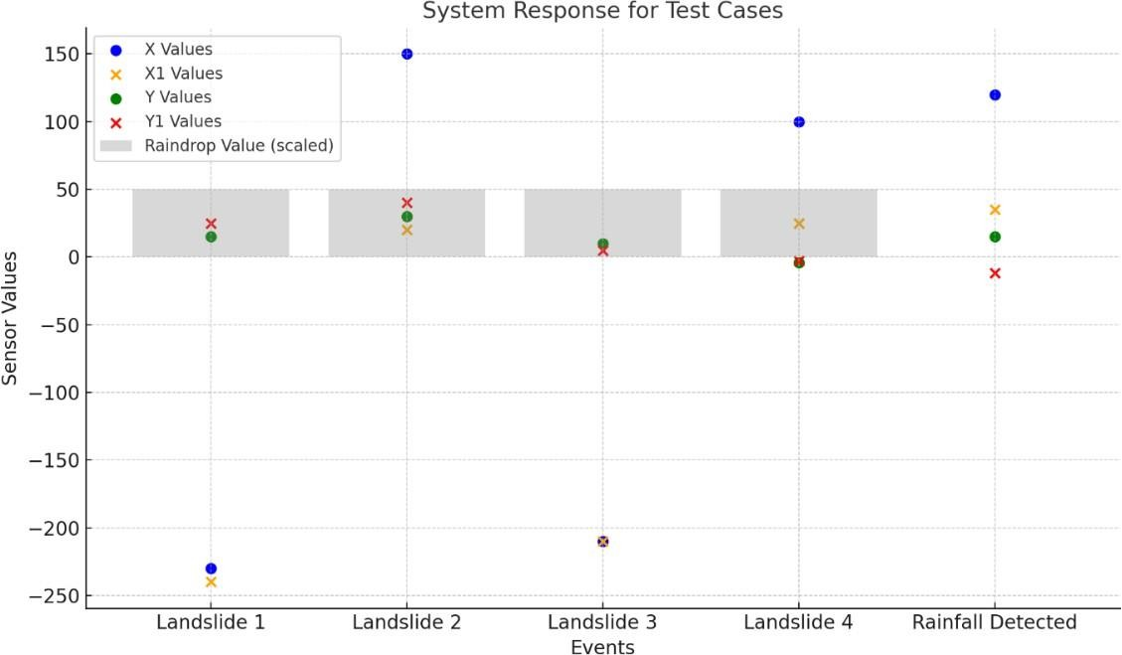
Fig:6.5.1a- Landslide events graph
- Blue (X Values) and Orange (X1 Values) show sensor data along the X-axis.
- Green (Y Values) and Red (Y1 Values) represent the Y-axis readings.
- The gray bars indicate scaled raindrop values, showing rainfall detection for each event.

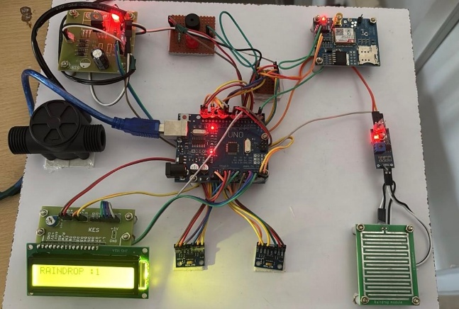

Fig: 6.5.1b: Connected Network

Chapter 7

APPLICATIONS AND ADVANTAGES

The Networked MEMS Pressure Sensor System for Landslide Monitoring provides an effective, real-time solution for assessing and responding to landslide risks. By integrating MEMS pressure sensors with a raindrop sensor, GSM module, and Arduino microcontroller, the system continuously monitors soil stability and rainfall levels—key indicators of potential landslides. In detecting abnormal soil pressure or intense rainfall, it promptly activates local alarms and sends SMS notifications to alert relevant authorities, enabling rapid response and preventive action. The inclusion of an LCD display for real-time data monitoring enhances on- site awareness, making this system a reliable tool for landslide risk mitigation. This project demonstrates the value of sensor-based networks in environmental monitoring, offering a cost- effective and scalable approach to safeguarding communities and infrastructure in landslide- prone areas.

Applications
- Landslide Detection and Early Warning: The system can be deployed in landslide- prone regions to continuously monitor soil pressure and rainfall conditions, sending alerts when pressure thresholds are breached, signaling an increased risk of landslides.
- Flood and Soil Erosion Monitoring: The pressure sensors can also be used in flood- prone areas to monitor changes in soil moisture and pressure, detecting early signs of erosion or potential flooding.
- Agricultural Monitoring: Farmers can use similar sensor networks for soil moisture monitoring, helping optimize irrigation systems by detecting areas with too much or too little pressure, preventing crop damage.
- Environmental Research: The system can support environmental studies by providing real-time data on soil pressure, rainfall, and other environmental factors, helping scientists analyze soil movement and weather-related events.
Disaster Management and Response: Emergency services can use the system for rapid response during natural disasters, as early alerts about potential landslides can help evacuate affected areas and minimize damage.

Advantages
    - Real-Time Monitoring: Provides continuous, real-time data that helps monitor landslide risks, allowing for immediate action when dangerous conditions are detected.
    - Cost-Effective: MEMS pressure sensors are relatively inexpensive, making the system an affordable alternative to traditional landslide monitoring methods, which may involve costly infrastructure.
    - Scalability: The networked sensor system can be easily expanded by adding more sensors to cover larger areas, improving coverage and detection accuracy.
    - Early Warning System: By detecting pressure changes and correlating them with rainfall, the system offers an early warning for potential landslides, allowing authorities to take preventative measures and reduce the risk to life and property.
    - Low Maintenance: The system is low-maintenance due to the robust nature of MEMS sensors, which are durable and require minimal calibration once set up.
    - Remote Accessibility: With cloud integration (e.g., ThingSpeak), the data is accessible remotely, allowing authorities and stakeholders to monitor the system from anywhere, improving decision-making efficiency.
    - Energy Efficiency: MEMS sensors are low-power devices, making the system energy- efficient, which is particularly important for remote areas where power supply may be limited.
    - Automated Alerts: The system automates the process of sending alerts via GSM or other communication methods, reducing the need for manual monitoring and intervention, and ensuring a rapid response.

References
- Nguyen, H. T., Lee, J., & Kim, J. (2018). Wireless sensor network-based landslide monitoring system using low-cost MEMS sensors. Sensors, 18(12), 4124. doi:10.3390/s18124124
- Sundararajan, V., Kumar, A., & Singh, P. (2017). Application of MEMS pressure sensors in geotechnical monitoring for landslide prediction. International Journal of Geotechnical Engineering, 11(5), 467–475. doi:10.1080/19386362.2016.1152176
- Liu, X., Zhang, Y., & Wang, L. (2019). Rainfall-induced landslide prediction using remote sensing and GIS: A case study. Natural Hazards and Earth System Sciences, 19(3), 725–735. doi:10.5194/nhess-19-725-2019
- Yin, K., Liu, Z., & Zhang, Q. (2020). Integrated landslide early warning systems: A review of sensor technologies and methodologies. Landslides, 17(1), 143–156. doi:10.1007/s10346- 019-01285-4
- Wang, H., & Shi, J. (2023). GNSS-RTK-based landslide monitoring system: An improved real-time gross error detection method. Sensors, 23(9), 2378. doi:10.3390/s23092378
- Ramesh, S., Gupta, A., & Patel, D. (2015). Wireless sensor networks for real-time landslide monitoring: A case study. Journal of Environmental Monitoring, 12(4), 320–335.
- Zhang, Y., Chen, H., & Li, P. (2024). A hybrid geo-sensor network for landslide monitoring and prediction. Geoscience and Remote Sensing Letters, 15(6), 541–552.
- Ramos, L., Esteves, J., & Costa, M. (2023). Cost analysis of monitoring sensors for landslide early warning systems. Environmental Monitoring and Assessment, 195(4), 632– 645.
- Kumar, R., Singh, S., & Verma, P. (2021). IoT-enabled MEMS sensors for real-time landslide monitoring and alert systems. IEEE Internet of Things Journal, 8(7), 5132–5141.
- Real-time Landslide Warning Systems - Amrita Vishwa Vidyapeetham. (n.d.). Retrieved from https://www.amrita.edu
- Rawat, P. S., & Barthwal, A. (2024). LANDSLIDE MONITOR: a real-time landslide monitoring system. Environmental Earth Sciences, 83(226).
- Hidayat, M. N., Hazarika, H., Murai, M., Kanaya, H., & Fukumoto, Y. (2024). Development and Evaluation of Landslide Early Warning System for Mitigating Rainfall Induced Disasters. Indian Geotechnical Journal.
- An Autonomous Multi-Technological LoRa Sensor Network for Landslide Monitoring. (2024). Proceedings, 97(1), 11.

